Hazard and Risk Management Procedure

# Appendix 3. Hierarchy of controls

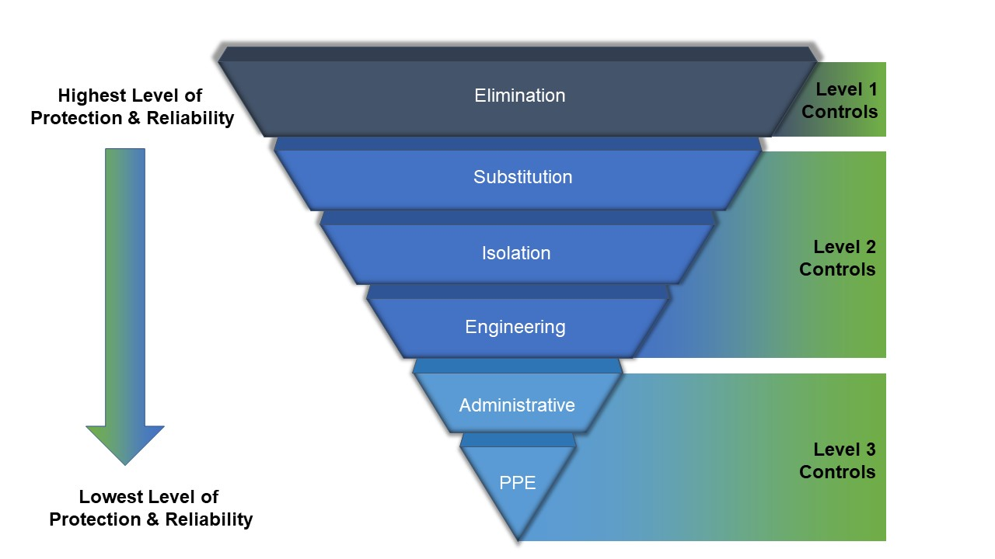

* 1. When considering risk controls, the hierarchy of control measures must be applied in the order of most effective to least effective as follows:
     1. **Elimination**. The most effective risk controls are ones that eliminate the risk entirely (level 1 control). This can be done by not introducing the hazard or not conducting the associated task. Examples of risk elimination are:
        1. eliminate risk of falls by conducting work at ground level
        2. eliminating a phase of an activity for which the risk does not outweigh the benefit of the activity.
  2. If it is not reasonably practicable to eliminate a risk, the risk must be minimised SFARP, by implementing one or more of the following level 2 controls:
     1. **Substituting**. Substitute (wholly or partly) the hazard giving rise to the risk with something that gives rise to a lesser risk – for example, substituting a hazardous chemical with something less harmful.
     2. **Isolating.** Physically separate the source of harm from people by distance or by barriers – for example ensuring that metal grinding activities are conducted well away from hazardous or combustible chemicals.
     3. **Engineering.** An engineering control is physical in nature, including a mechanical device or process – for example, using mechanical devices such as trolleys or hoists to move heavy objects.
  3. If a risk remains following the application of level 2 controls, it must be minimised SFARP using one or more of the following level 3 controls (in order of precedence):
     1. **Administrative.** Administrative actions are work methods or procedures that are designed to minimise a risk – or example, checklists, signage, training, and practice or rehearsals.
     2. **Personal Protective Equipment (PPE).** PPE limits harmful exposure to a hazard but only if worn correctly and suitable for the task. Examples of PPE include earmuffs, gloves, safety glasses and helmets.
  4. The purpose of grouping administrative actions and PPE under level 3 is to highlight that neither of these risk controls control the hazard at the source. They rely on human behaviour and supervision and, used on their own, tend to be least effective in minimising risks. Being both rated as level 3 does not mean they carry equal legal status or effectiveness – PPE is rated less effective than administrative actions; hence the order of precedence to consider administrative actions before PPE. Note that a variety of risk controls should be used to manage a risk—no single element of the hierarchy needs to operate in isolation.