Additional Requirements for Workshops, Fieldwork and Laboratories

Examples of Standards applying to Electrical Equipment

Electrical Equipment | Example
Single Phase RCD protected EPOD minimum IP rating of IP 33  Minimum standard for hostile use in field work, or energised from generator (non-mains power source) | 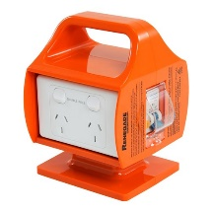
3 Phase Plug into Single phase outlets RCD protected | 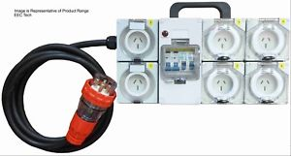
3 Phase Plug with 3 Phase outlets with RCD protection | 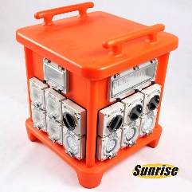
Light Duty 240V 10A Extension Lead for non-hostile areas such as Office spaces only | 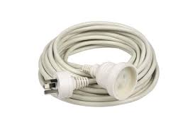  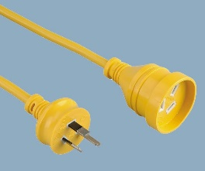
25m 240V 15A Heavy Duty lead, can also get in 10A heavy duty  For workshops and fieldwork  NOTE: 25M is the max length for any extension lead | 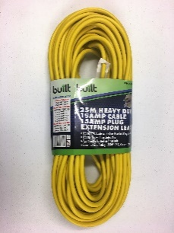
Double Adaptors - NOT FOR USE anywhere on University property | 