**Electrical Enclosure Ingress Protection (IP) Rating**

The IP rating is a two-digit number established by the International Electro Technical Commission, is used to provide an IP rating to a piece of electrical equipment or to an enclosure for electrical equipment. The symbols that consist of the two code letters IP and a code numeral for the amount of the protection. Example: IP65 the two digits represent different forms of environmental influence:

* The first digit represents protection against ingress of solid objects.
* The second digit represents protection against ingress of liquids.

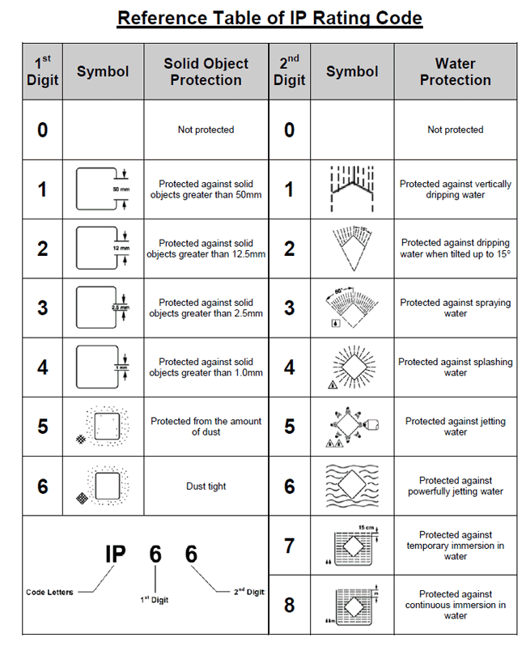The larger the value of each digit, the greater the protection. As an example, a product rated IP54 would be better protected against environmental factors than another similar product rated as IP42.